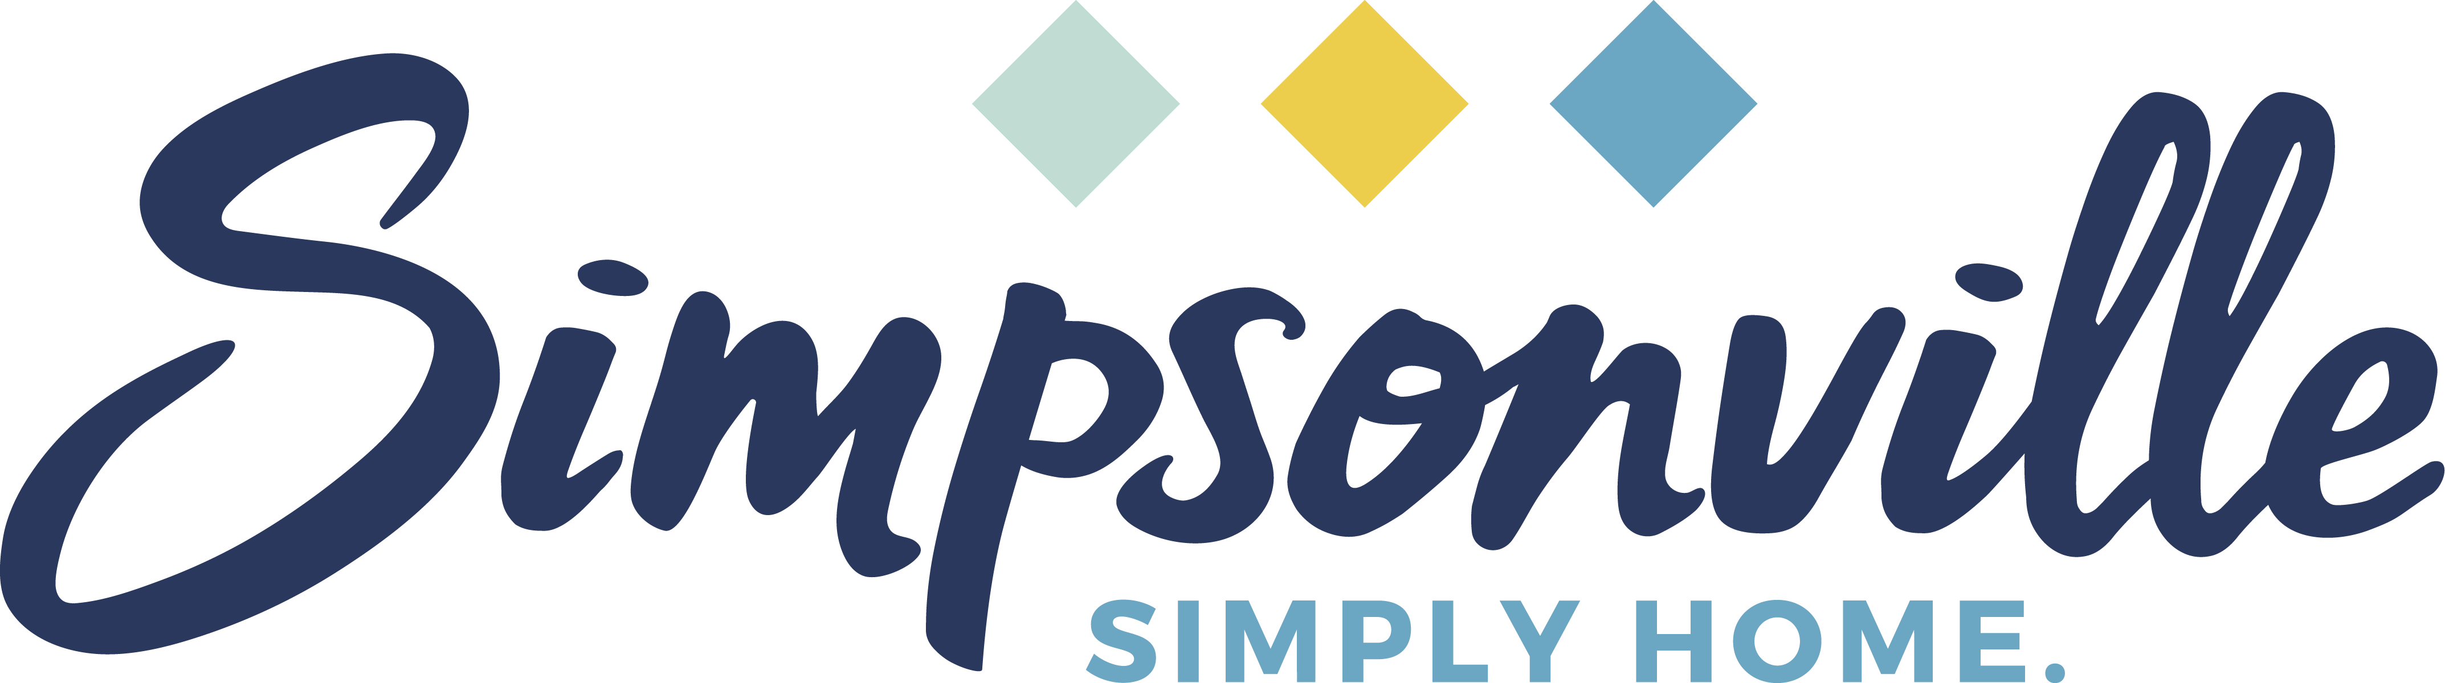

Request for Qualifications: Public Facilities
City of Simpsonville
118 N.E. Main St.
Simpsonville, S.C. 29681

Call Type: Architecture
State: South Carolina
Submission Deadline: April 16, 2021

Contact: Dianna Gracely, City Administrator
Contact Email: dianna@simpsonville.com
Contact Phone: 864-967-9526

PROJECT DETAILS & BACKGROUND INFORMATION
The City of Simpsonville is a municipality of more than 23,000 people in Greenville County. Downtown Simpsonville is retaining its small-town charm in the midst of positive smart growth with recent improvements, such as an alleyway with an outdoor seating area, and a new section of the Swamp Rabbit Trail. Simpsonville rebranded in 2019 with the new tagline “Simply Home,” new logo and new icon. This project will construct two buildings: one fire department headquarters and one City Hall/police department, approximately 15,000 and 20,000 square feet respectively.

LOCATION
City Park

REQUIREMENTS
- Resume(s) of project personnel
- Letter of Interest no longer than 500 words describing professional experience, style of work and interest in the project.
- Three (3) to five (5) images of completed work demonstrating an ability to conceptualize, design, and supervise construction of projects
- Two (2) professional references that include name, title, address, relationship, phone number and email address
- Optional: Up to three (3) support materials, such as reviews, news articles or other relevant information

SELECTION PROCESS
Submissions will be judged and scored on the following measures with a maximum score of 100 points:
- Design Excellence (30 points): The firm/team's work reflects excellence, innovation and originality as evidenced by quality of design; demonstrates professional approaches to processes and presentation and communicates a unique vision or perspective
- Professional Experience (30 points): The firm/team’s professional experience is adequate to meet the demands of the project, including a proven ability to meet project budgets and deadlines and perform work in a timely and professional manner. Public facilities experience is preferred.
- Experience Working on a Project of Similar Scale (30 points): Previous work that can specifically demonstrate the successful completion of projects. Experience with public engagement is a plus.
- Proximity to project location (10 points): The firm's location and proximity to the project site will be factored into the overall score.
Submissions will be reviewed by a selection committee comprised of city staff and elected officials. City Council will have the final decision regarding contracting.
TIMELINE
- Request for Qualifications issued: March 17, 2021
- Request for Qualifications due: April 16, 2021
- Selection Process: May 2021
- Contract(s) awarded: June 2021
- Target start of project: November 2021
- Target completion date: September 2022

PROJECT BUDGET
The total project budget is $12,500,000.

SUBMISSION PROCEDURES
Three hard copies and one electronic submittal must be directed to the following:

Attn: Dianna Gracely
Re: RFQ Public Facilities
118 N.E. Main St.
Simpsonville, S.C. 29681

SUBMISSION DEADLINE
All materials must be received by 5 p.m. Eastern Standard Time on April 16, 2021

QUESTIONS
Please direct all questions or requests for assistance to City Administrator Dianna Gracely at dianna@simpsonville.com.

